
Announcement of Mae Chaem Police Station
Subject honest intentions in the administration of Mae Chaem Police Station
------------------------------------
Mae Chaem Police Station would like to announce intentions that we will administer works with honesty in accordance with the principles of good governance creating work transparency that can be verified. In addition.

It is our responsibility for building confidence in the society that Mae Chaem Police Station is committed to combat corruption in all forms and intend to be an organization with good governance and work transparency, so it is consistent with the value of Royal Thai Police as “being honest and fair” which we will proceed as follows.

1) Strictly and completely perform duties in accordance with laws, rules and regulations as well as encourage police officers to perform duties in accordance with laws, rules and regulations.

2) Cultivate and raise awareness of anti-corruption value, lead police officers to know how to distinguish between their own interests and common interests consequently, the moral awareness will be cultivated and the prevention of corruption will be promoted in the organization, including an effective and powerful internal counterbalance to manage police officers of Mae Chaem Police Station to recognize harmfulness and threat of corruption to Mae Chaem Police Station and the nation, in order to create a sustainable culture of anti-corruption.

3) Do not accept corrupt behavior and do not tolerate corruption.

4) Perform duties with transparency, equality, fairness, honesty, quickness and efficiency in order to keep up with the dynamic of corruption and consistent with the standard in the performance of duty.

5) Administrative works with good governance and create a culture of morality in the organization, manage a budget with transparency and cost effectiveness creating the utmost benefit to the government sector and also be ready to take responsibility for outcomes if Mae Chaem Police Station’s operations affect and cause damage to the society as a whole. It is hereby publicly announced.

This announcement is hereby issued on March 5th, 2025

Police Colonel 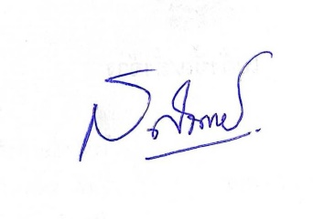
(Satitchai Nitayawan)
Superintendent of Mae Chaem Police Station

